***LAB - 23***

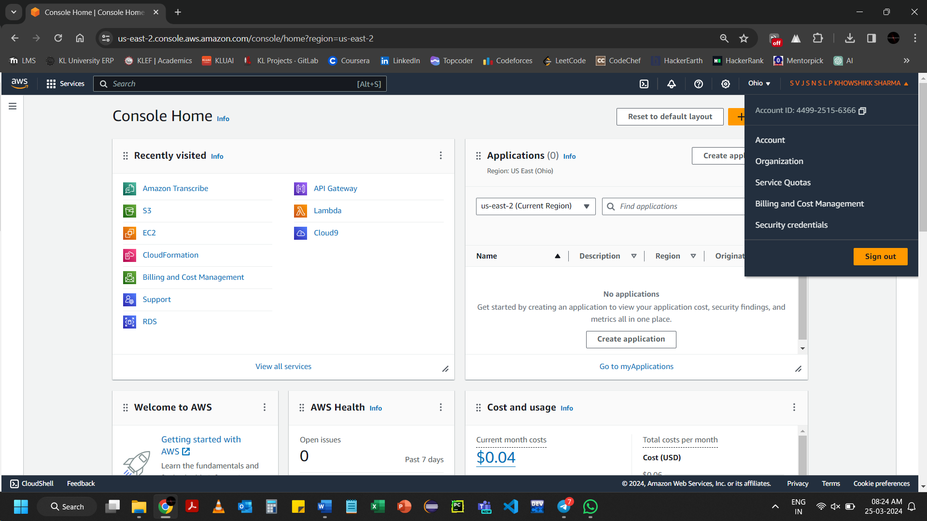

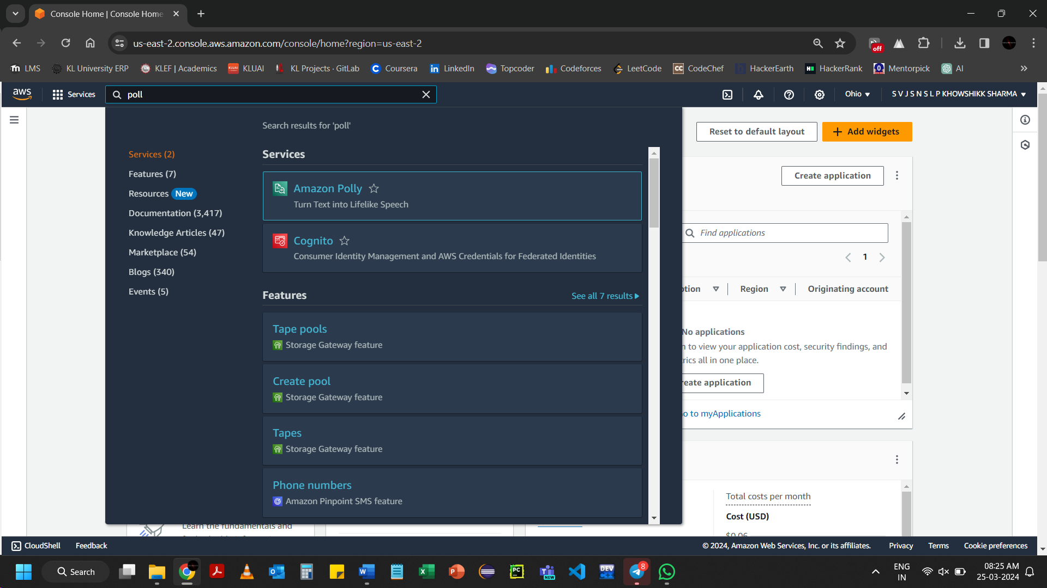

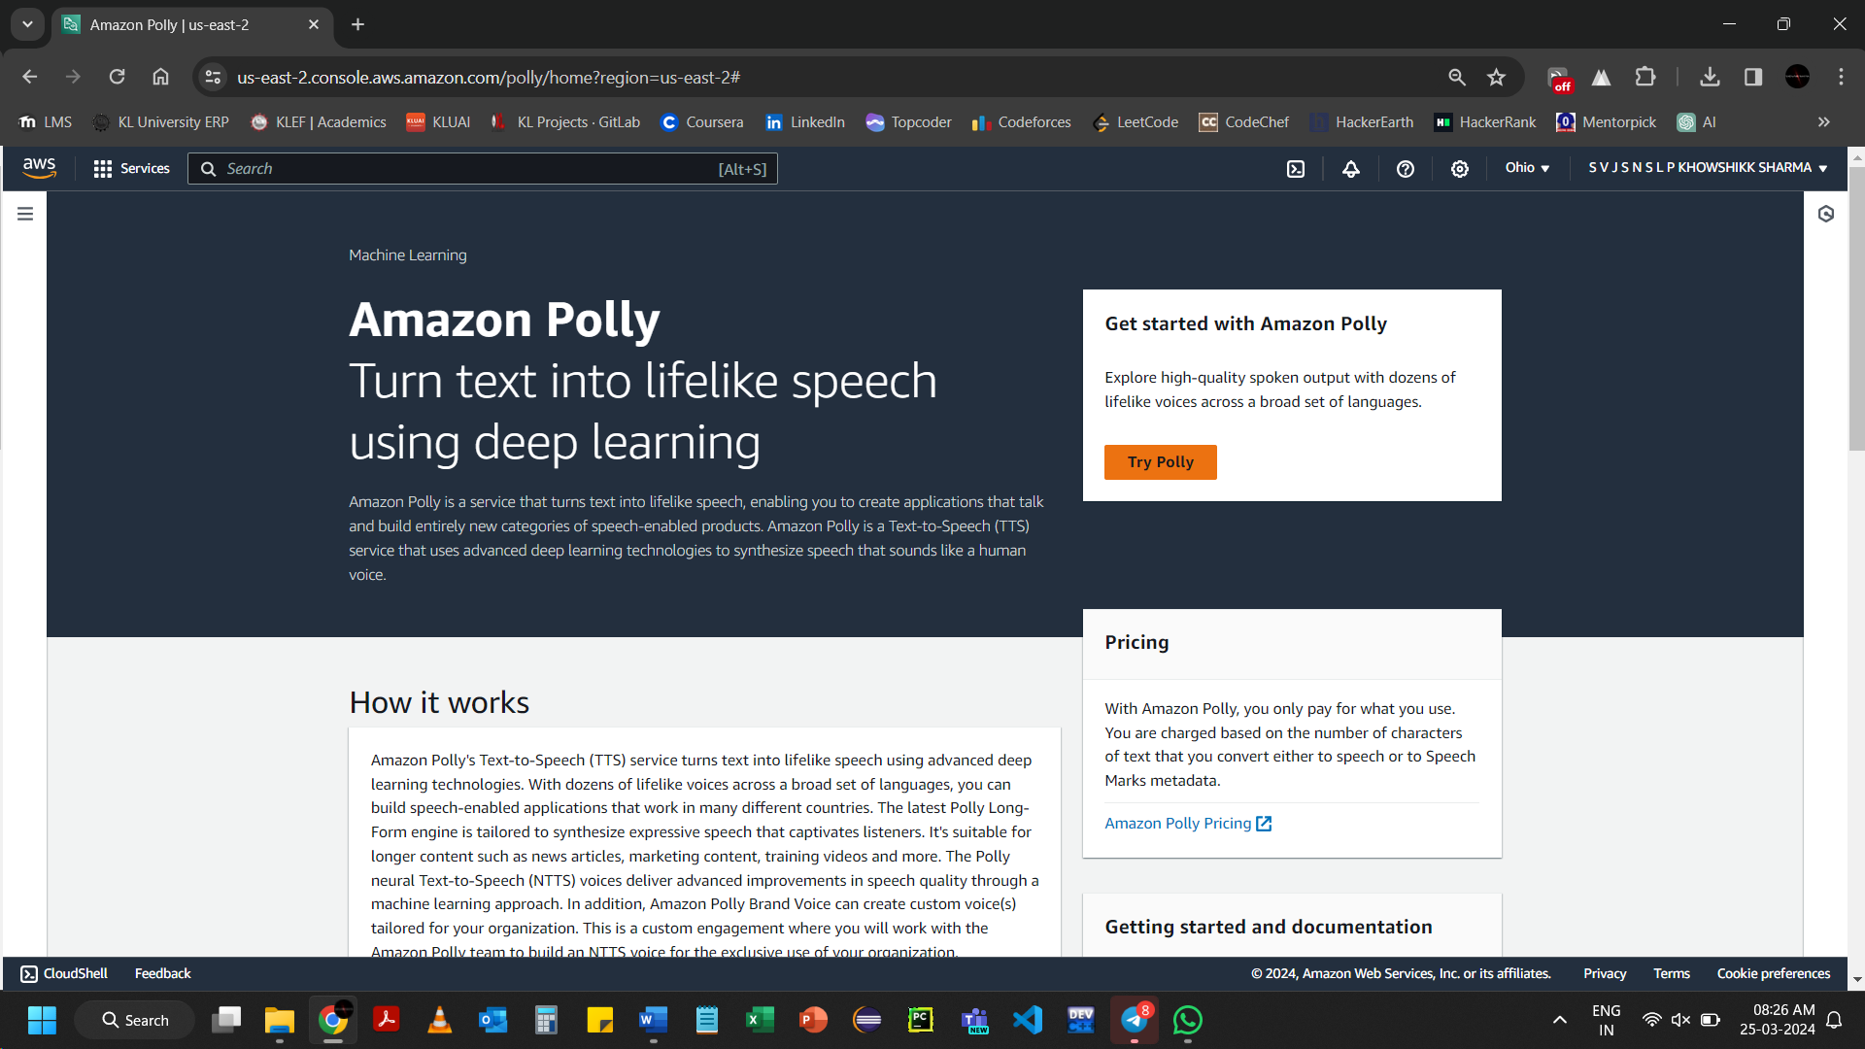Click on Try Polly

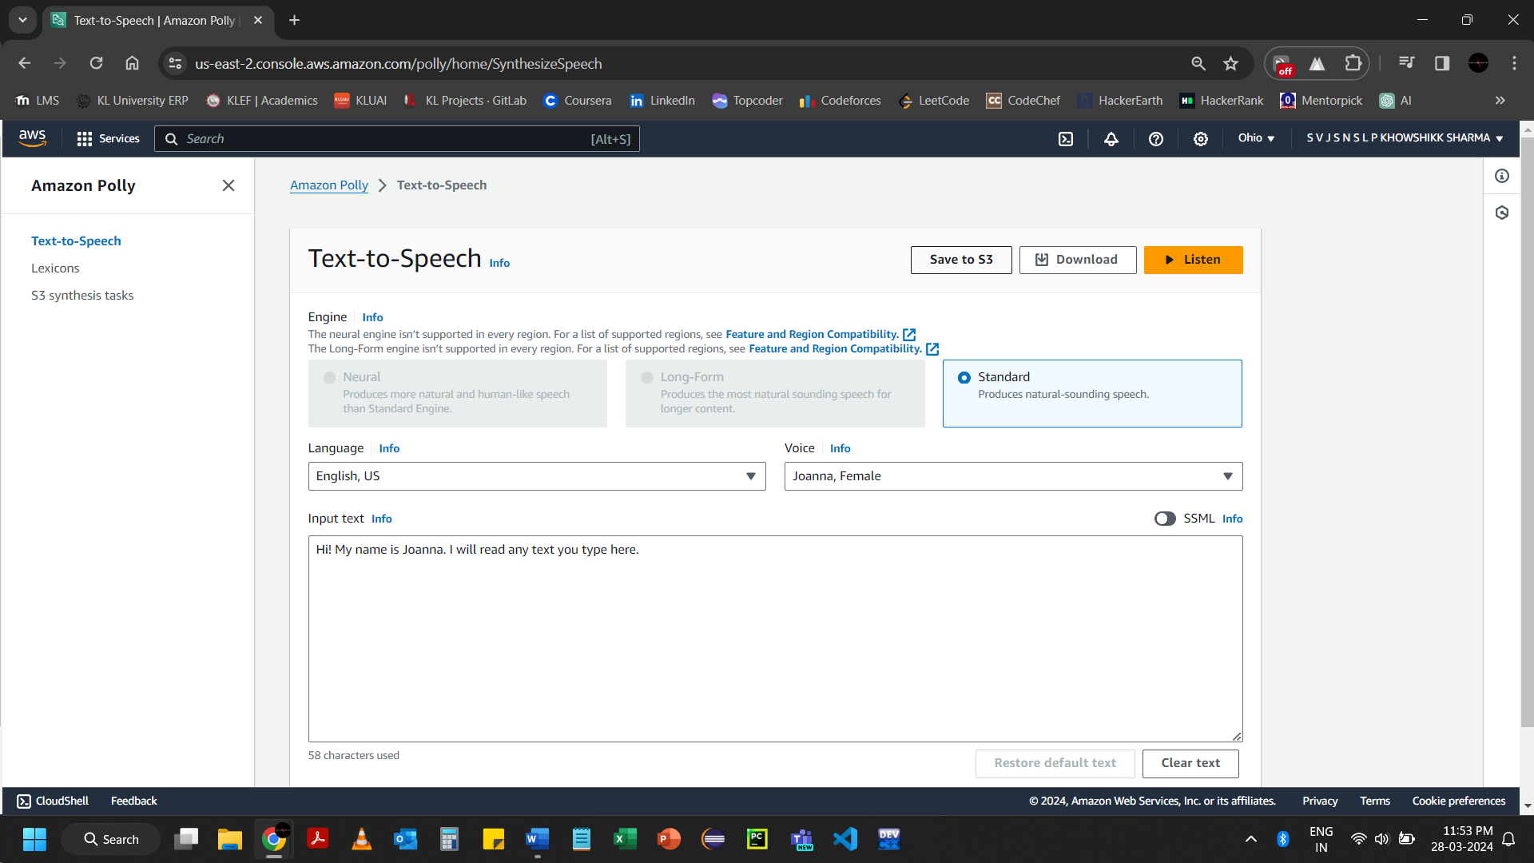Click on Listen, when you finished typing in Input text

It will automatically starts reading and stopped after finish of you typed text in Input text